**Name of the Project: Song_Album**

**Server Type: MS SQL Server 2012**

Creating the database in the name of “Song_Album”.

**Query for creating the Database:**

Create database Song_Album

**Screenshot:**

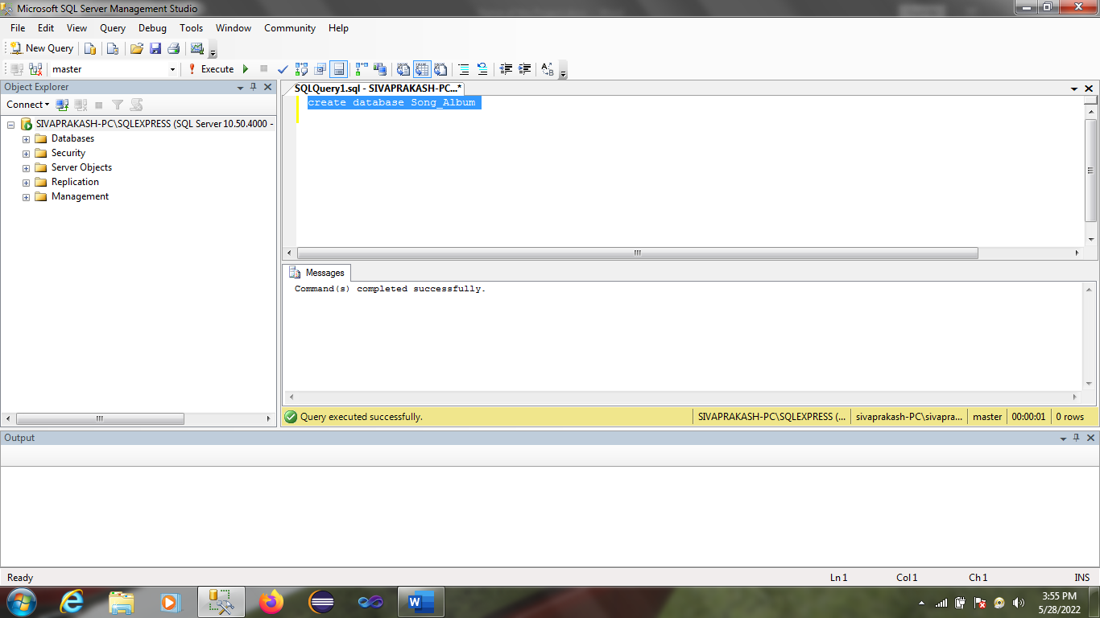

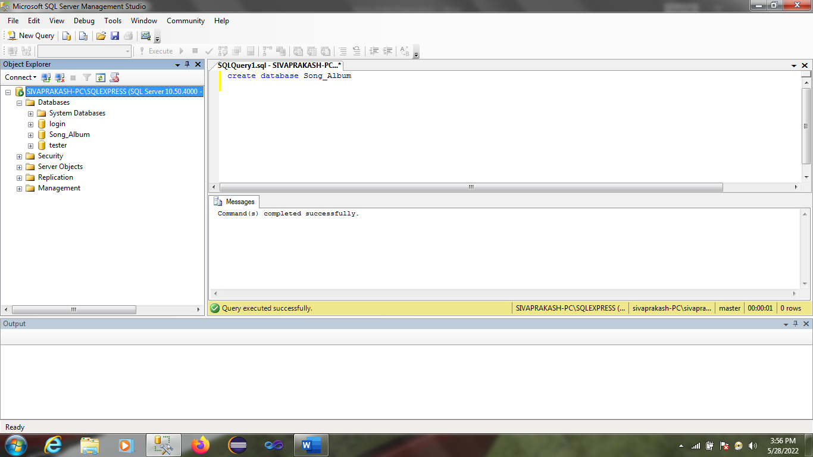

**Query for creating the table Artist:**

create table Artists(

Artistid int identity(1,1) primary key,

ArtistName nvarchar(50),

DOB date,

Bio nvarchar(max)

);

**Screenshot:**

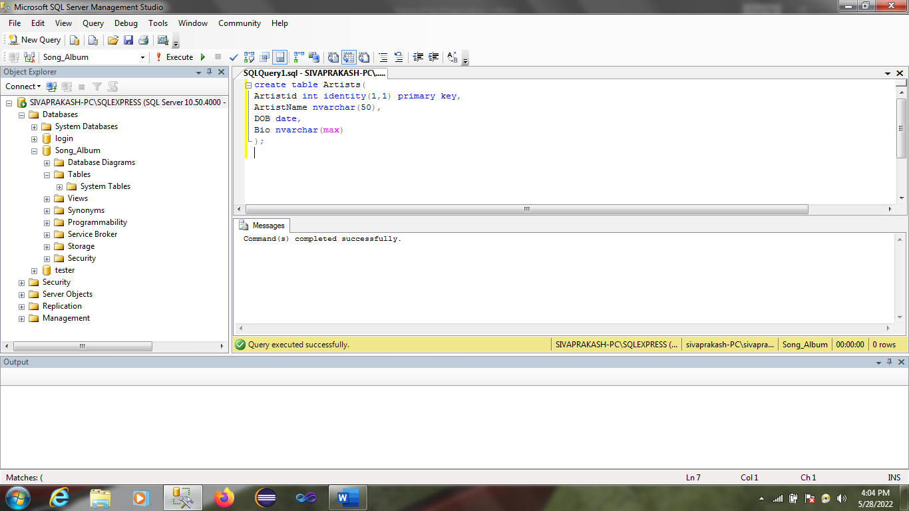

**Query for creating the table Songs:**

create table Songs(

Songid int identity(10,10) primary key,

DateofRelease date,

cover varbinary(max)

);

**Screenshot:**

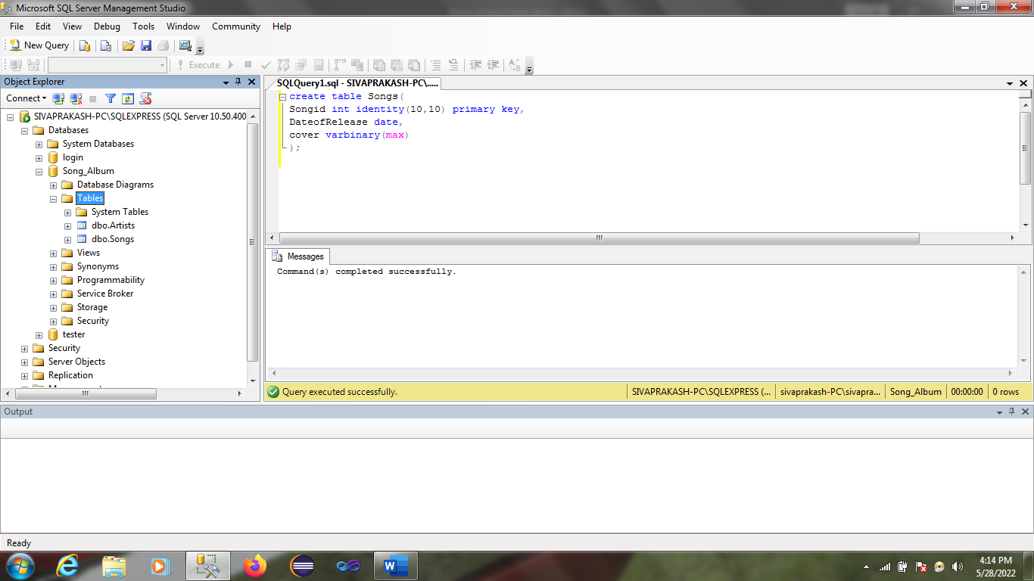

**Query for creating the table Users:**

create table Users(

Userid int identity(100,100) primary key,

Email varchar(100)

);

**Screenshot:**

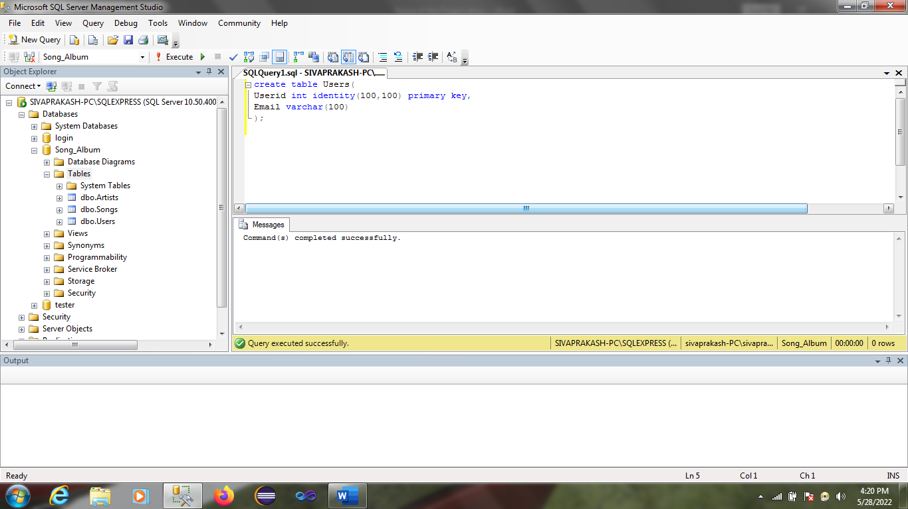

**Query for creating the table Artist_Songs:**

create table Artist_Songs(

Artistid int foreign key references Artists(Artistid),

Songid int Foreign key references Songs(songid)

);

**Screenshot:**

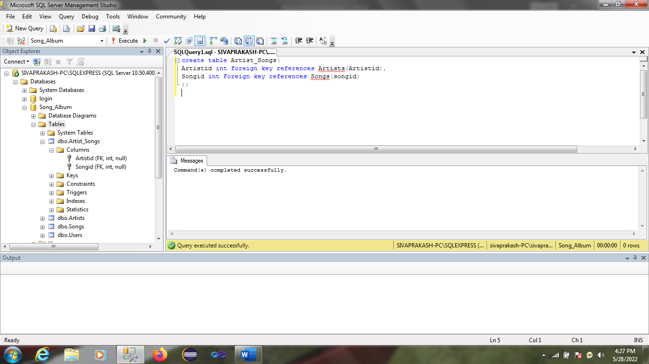

**Query for creating the table Artist_Songs:**

create table Song_Rating(

Userid int foreign key references Users(Userid),

Songid int Foreign key references Songs(songid),

Rating int

);

**Screenshot:**

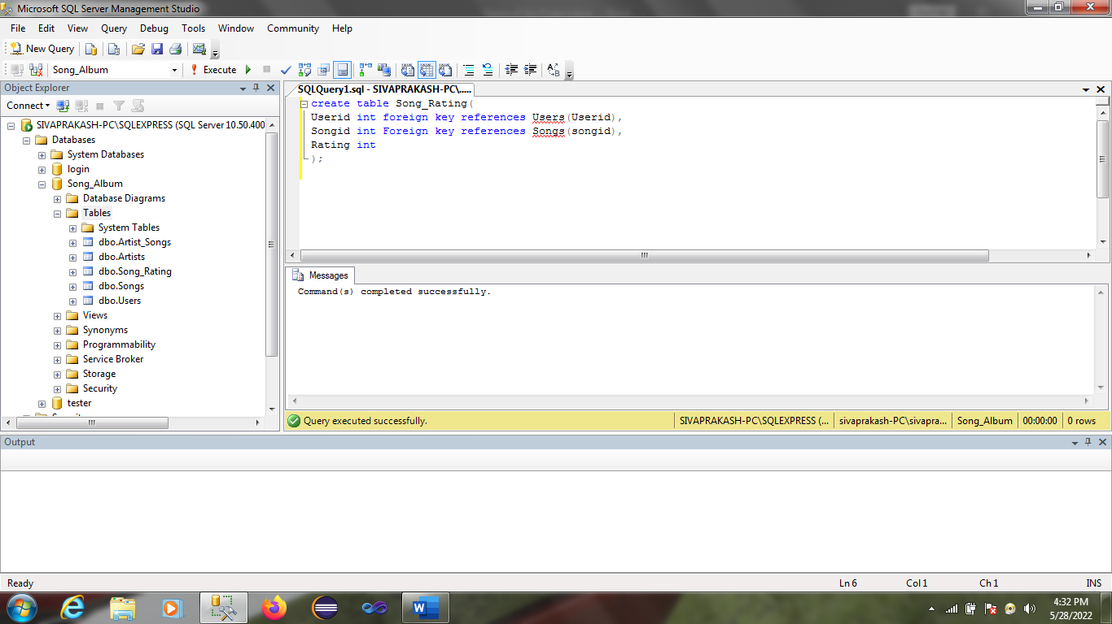

**Displaying all the content in the tables:**

select * from Artists

select * from Songs

select * from Users

Select * from Artist_Songs

Select * from Song_Rating

**Screenshot:**

